**Madison Heights Community Coalition**

300 West 13 Mile Road

Madison Heights, MI 48071

248.837.2665

mhcfc@madison-heights.org

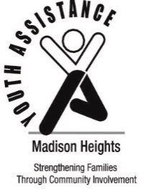

**Madison Heights**

**Youth Assistance**

31201 Dorchester Avenue

Madison Heights, MI 48071

248.589.6860

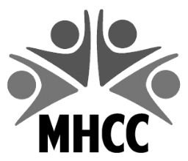

2025 YOUTH RECOGNITION PROGRAM

RECOGNITION CRITERIA

1. Honoree Criteria:
   * + A student must either reside in Madison Heights, or attend school in Madison Heights.
     + Any student in 1st through 12th grade.
     + Students should be considered for showing **EXCEPTIONAL SERVICE/KINDNESS TO OTHERS** i.e. displays incredible initiative and extreme concern for others in community **or in the classroom**. Commitment and individual initiative are qualities considered.
     + Students should also be considered if they are **OVERCOMING PERSONAL CHALLENGES** and have made achievements in personal growth, social development, attitudes and behaviors**.**
       - * Making positive changes and progress is evident
         * Overcoming significant personal hardships, obstacles or circumstances
     + ***Paid services, required community service, activities for school credit, class assignments, scouts, sports, National Honor Society, church or the courts are NOT eligible****.*
2. High school seniors may be eligible for continuing education scholarships.
3. Nominators may be any adult (immediate relatives are excluded) or organization.
4. Nominations should be submitted using the 2025 Youth Recognition Nomination form.
   * + Electronic forms are available by scanning this QR code with a cell phone.
5. Illegible or incomplete forms will not be considered.
6. **Each school will have up to five students recognized.**
7. Due to the fact that this is an individual award, group selections are ineligible. However, selections for an individual who stands out in his/her group are welcome.

If you need additional information, please do not hesitate to call Deb at the **MHYA office, 248.589.6860** or Kimberly at the **MHCC office, 248.837.2665.**

**Recognition forms DUE BY MARCH 28, 2025.**

**Breakfast is Tuesday, May 13, 2025.**

Send recognition forms to: **Madison Heights Community Coalition**

**300 West Thirteen Mile Road**

**Madison Heights, MI 48071**

Or email to: **MHCC@madison-heights.org**